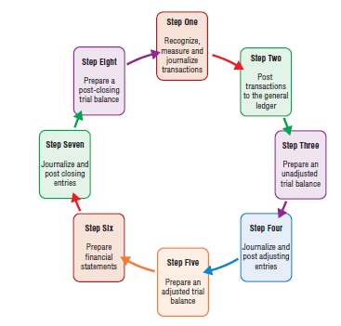
  - The accounting cycle is repeated for every accounting period.
    - The accounting period can be defined as a month, a quarter, or a year.
      - May or may not follow the same period as a calendar year.
      - A fiscal year is any consecutive 12-month period that a business adopts as its accounting year.
How Does a Company Accurately Report Its Income?
- Understand the revenue recognition and matching principles.
  - Cash-basis accounting is the accounting method that records revenues when cash is received and expenses when cash is paid.
  - Accrual accounting is the accounting method that records revenues when earned and expenses when incurred without regard to when cash is exchanged.
    - Required by GAAP, accrual accounting must follow the revenue recognition and matching principles.
      - The revenue recognition principle states that revenues should be recognized, or recorded, when they are earned regardless of when cash is received.
      - The matching principle states that expenses should be matched with the revenues they helped generate. In other words, expenses should be recorded when they are incurred regardless of when they are paid for.
    - Accruals are revenues that are earned or expenses that are incurred before cash has been exchanged.
    - Deferrals (prepayments) are cash that is received or paid before revenue has been earned or expenses have been incurred.
    - Accruals and deferrals are summarized in the following exhibit.
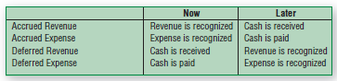
  - Adjusting entries are journal entries made at the end of the accounting period to measure the period’s income accurately and bring the related asset and liability accounts to correct balances before the financial statements are prepared.
What Is the Role of Adjusting Entries, and When Are They Prepared?
- Understand the four types of adjustments, and prepare adjusting entries.
  - Two types of adjustments are made for accruals.
    - Accrue, or record, unrecorded revenues. Revenues are recorded in the current period by debiting a receivable and crediting revenue.
    - Accrue, or record, unrecorded expenses. Record the expenses in the current period by debiting an expense and crediting a liability.
  - Two types of adjustments are made for deferrals (prepayments).
    - Divide unearned revenues between periods. When payment is received in advance from a customer for goods or services, cash is debited. Since the customers are owed for the goods or services, a liability account, Unearned Revenue, is credited (also called deferred revenue). Once the customer receives the goods or services, an adjusting entry is prepared in which the Unearned Revenue account is debited for the value of the goods or services received and a Revenue account is credited for this same amount (since the exchange is complete and the revenue is now earned).
    - Prepaid expenses are amounts that are assets of a business because they represent items that have been paid for but will be used later (also called deferred expenses). Divided into periods, examples include these following: prepaid expenses, supplies, buildings, equipment, and other assets. These items are recorded as assets when they are purchased because the item that was paid for has not yet been used up. Therefore, an asset account is debited and cash is credited to record the purchase. Once part, or all, of the item is used up, an adjusting entry is prepared in which an expense account is debited and the related asset is credited for that portion that has been used.
  - An unadjusted trial balance is a trial balance report that is prepared at the end of the accounting period prior to the recording of adjusting entries.
  - Accounts receivable are recorded, representing accrued revenues, when a customer receives a product or service before payment is made.
  - Salaries payable, accrued expenses, represents a liability owed to employees who have earned their wages, but not yet been paid. Accrued expenses are expenses that have been incurred prior to being paid for.
  - Deferred revenue is a liability that is created when a business collects cash from customers in advance of providing goods or services (also called unearned revenue). An example, using consulting services, is illustrated.
  - Deferred expenses are amounts that are assets of a business because they represent items which have been paid for, but will be used at a later date. Also called prepaid expenses.
    - Examples to illustrate the initial and adjusting journal entries include prepaid rent, supplies inventory and long-term assets.
    - Long-term assets, or fixed assets, are assets that last for more than one year.
      - Examples include land, buildings, equipment, and furniture.
      - Depreciation is the allocation of the cost of a long-term asset to expense over its useful life. Land is never depreciated as it is never “used up.”
      - Straight-line depreciation is a method of estimating depreciation (Cost of the Asset –Salvage Value)/Useful like of the asset.
      - Salvage value is the estimated value of a long-term asset at the end of its useful life.
      - The formula to calculate depreciation using the straight-line method is as follows:
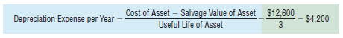
      - Accumulated Depreciation is a contra-asset account that reflects all of the depreciation recorded for an asset to date.
      - A contra-account is an account that is linked to another account and has a normal balance that is opposite of the account it is linked to.
      - The net value is the amount found by subtracting the balance of a contra-account from the balance of the account it is linked to.
      - The book value is the asset’s cost minus its accumulated depreciation; also called carrying value.
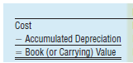

How Are Financial Statements Prepared from an Adjusted Trial Balance?
- Prepare financial statements from an adjusted trial balance.
  - An adjusted trial balance is a list of all accounts of a business with their adjusted balances.
    - Prepared prior to preparing the financial statements to make sure debits equal credits.

Accruals and deferrals can be summarized as follows:
      - With an accrued revenue or expense, a revenue or expense is recorded first when the revenue is earned or the expense is incurred and cash is received or paid later.
      - With a deferred revenue or expense, cash is received or paid first. The revenue or expense is recorded later as the revenue is earned or the expense is incurred.
      - The below Exhibit summarizes the accrual and deferral adjustments.
